Guinea-Bissau

## Population Data

The data set shows the political stability estimate of the country each year.

## # A tibble: 23 x 5  
## country iso3c date population popCategory5  
## <chr> <chr> <dbl> <dbl> <chr>   
## 1 Guinea-Bissau GNB 1996 1110833 very small   
## 2 Guinea-Bissau GNB 1997 1132510 very small   
## 3 Guinea-Bissau GNB 1998 1154371 very small   
## 4 Guinea-Bissau GNB 1999 1177131 very small   
## 5 Guinea-Bissau GNB 2000 1201301 very small   
## 6 Guinea-Bissau GNB 2001 1227106 very small   
## 7 Guinea-Bissau GNB 2002 1254453 very small   
## 8 Guinea-Bissau GNB 2003 1283305 very small   
## 9 Guinea-Bissau GNB 2004 1313492 very small   
## 10 Guinea-Bissau GNB 2005 1344930 very small   
## 11 Guinea-Bissau GNB 2006 1377581 very small   
## 12 Guinea-Bissau GNB 2007 1411543 very small   
## 13 Guinea-Bissau GNB 2008 1446936 very small   
## 14 Guinea-Bissau GNB 2009 1483921 very small   
## 15 Guinea-Bissau GNB 2010 1522599 very small   
## 16 Guinea-Bissau GNB 2011 1562989 very small   
## 17 Guinea-Bissau GNB 2012 1604979 very small   
## 18 Guinea-Bissau GNB 2013 1648257 very small   
## 19 Guinea-Bissau GNB 2014 1692439 very small   
## 20 Guinea-Bissau GNB 2015 1737202 very small   
## 21 Guinea-Bissau GNB 2016 1782437 very small   
## 22 Guinea-Bissau GNB 2017 1828146 very small   
## 23 Guinea-Bissau GNB 2018 1874309 very small

# Population growth data

## # A tibble: 23 x 5  
## country iso3c date popGrowth popGrowthCat5   
## <chr> <chr> <dbl> <dbl> <chr>   
## 1 Guinea-Bissau GNB 1996 2.00 moderate growth rate  
## 2 Guinea-Bissau GNB 1997 1.93 moderate growth rate  
## 3 Guinea-Bissau GNB 1998 1.91 moderate growth rate  
## 4 Guinea-Bissau GNB 1999 1.95 moderate growth rate  
## 5 Guinea-Bissau GNB 2000 2.03 moderate growth rate  
## 6 Guinea-Bissau GNB 2001 2.13 moderate growth rate  
## 7 Guinea-Bissau GNB 2002 2.20 moderate growth rate  
## 8 Guinea-Bissau GNB 2003 2.27 moderate growth rate  
## 9 Guinea-Bissau GNB 2004 2.33 moderate growth rate  
## 10 Guinea-Bissau GNB 2005 2.37 moderate growth rate  
## 11 Guinea-Bissau GNB 2006 2.40 moderate growth rate  
## 12 Guinea-Bissau GNB 2007 2.44 moderate growth rate  
## 13 Guinea-Bissau GNB 2008 2.48 moderate growth rate  
## 14 Guinea-Bissau GNB 2009 2.52 high growth rate   
## 15 Guinea-Bissau GNB 2010 2.57 high growth rate   
## 16 Guinea-Bissau GNB 2011 2.62 high growth rate   
## 17 Guinea-Bissau GNB 2012 2.65 high growth rate   
## 18 Guinea-Bissau GNB 2013 2.66 high growth rate   
## 19 Guinea-Bissau GNB 2014 2.65 high growth rate   
## 20 Guinea-Bissau GNB 2015 2.61 high growth rate   
## 21 Guinea-Bissau GNB 2016 2.57 high growth rate   
## 22 Guinea-Bissau GNB 2017 2.53 high growth rate   
## 23 Guinea-Bissau GNB 2018 2.49 moderate growth rate

## Population trend

The plot shows the population trend of the country.

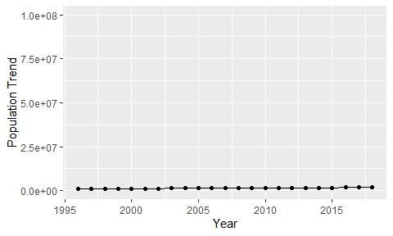

Political Stability Trend

# Population growth trend

The plot shows the population growth rate trend of the country.

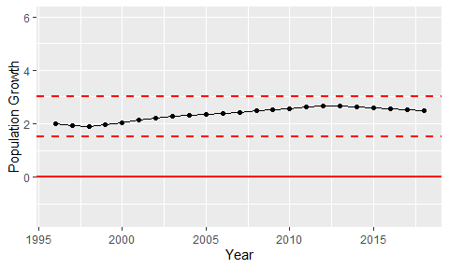

Population Growth Trend